Practical-4
Problem Definition:
Implement epidemic diffusion models on real-world network datasets and investigate the propagation behavior across the network.
- Execute SIS and SIR diffusion simulations.
- Visualize the spread process over multiple iterations.
- Examine the impact of highly connected nodes on diffusion dynamics.

MANDATORY SUBMISSION REQUIREMENTS
Student ID Verification:
- In Code: Declare your Student ID (Enrollment Number) and Full Name as variables and header comments at the very top of your Python script (e.g., STUDENT_ID = "23CS001").
- In Console Output: Print your Student ID and Name at the start of execution so it appears at the top of all terminal output (print(f"Student ID: {STUDENT_ID}")).
- In Plot Titles: Display your Student ID in the main title of all generated network plots, charts, and visualizations (e.g., plt.title(f"Network Graph - {STUDENT_ID}")).
Screenshots Required: You must include clear screenshots showing:
- Terminal/Console Output displaying your printed Student ID and execution results.
- Visualization Graphs & Plots showing your Student ID rendered directly in the graph title.
Note: Submissions without the Student ID clearly visible in the source code, execution logs, and graph titles will not be evaluated.
___________________________________________________________________________
Tools required:
- Dataset: Facebook Network Dataset
- Libraries: Python, NetworkX, Matplotlib / NDlib

Source Code
(Paste Python Code Here (SIS/SIR Simulation Logic))
# =============================================================================
# Practical-4: Epidemic Diffusion Models on Real-World Networks
# Student ID: 23CE115
# Student Name: Priya Pedhadhiya
# =============================================================================
import networkx as nx
import matplotlib.pyplot as plt
import random
import numpy as np
# 1. Mandatory Student Verification Output
STUDENT_ID = "23CE115"
STUDENT_NAME = "Priya Pedhadhiya"
print("==================================================")
print(f"Student ID: {STUDENT_ID}")
print(f"Student Name: {STUDENT_NAME}")
print("==================================================")
# 2. Network Construction
G = nx.barabasi_albert_graph(n=1000, m=5, seed=42)
print(f"Network Generated Successfully!")
print(f"- Nodes: {G.number_of_nodes()}, Edges: {G.number_of_edges()}")
# 3. Model Simulation Definitions
def simulate_sir(G, beta=0.08, gamma=0.03, steps=60, seed_nodes=None):
states = {node: 'S' for node in G.nodes()}
if seed_nodes is None:
num_initial = max(1, int(len(G) * 0.01))
seed_nodes = random.sample(list(G.nodes()), num_initial)
for node in seed_nodes:
states[node] = 'I'
history_S, history_I, history_R = [], [], []
for step in range(steps):
counts = {'S': 0, 'I': 0, 'R': 0}
for n in states:
counts[states[n]] += 1
history_S.append(counts['S'])
history_I.append(counts['I'])
history_R.append(counts['R'])
new_states = states.copy()
for node in G.nodes():
if states[node] == 'I':
for neighbor in G.neighbors(node):
if states[neighbor] == 'S' and random.random() < beta:
new_states[neighbor] = 'I'
if random.random() < gamma:
new_states[node] = 'R'
states = new_states
return history_S, history_I, history_R
def simulate_sis(G, beta=0.06, gamma=0.04, steps=60, seed_nodes=None):
states = {node: 'S' for node in G.nodes()}
if seed_nodes is None:
num_initial = max(1, int(len(G) * 0.01))
seed_nodes = random.sample(list(G.nodes()), num_initial)
for node in seed_nodes:
states[node] = 'I'
history_S, history_I = [], []
for step in range(steps):
counts = {'S': 0, 'I': 0}
for n in states:
counts[states[n]] += 1
history_S.append(counts['S'])
history_I.append(counts['I'])
new_states = states.copy()
for node in G.nodes():
if states[node] == 'I':
for neighbor in G.neighbors(node):
if states[neighbor] == 'S' and random.random() < beta:
new_states[neighbor] = 'I'
if random.random() < gamma:
new_states[node] = 'S'
states = new_states
return history_S, history_I

Execution Results & Simulation Plots
- SIR Model Plot: (Paste Susceptible-Infected-Recovered curves over time steps)
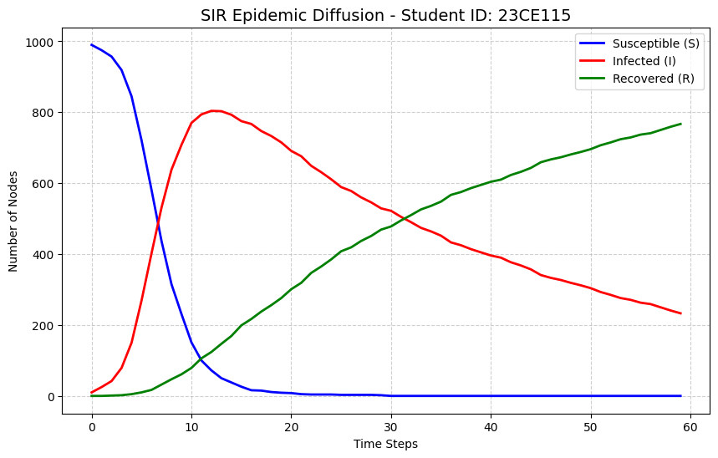

- SIS Model Plot: (Paste Susceptible-Infected-Susceptible state curves over time steps)
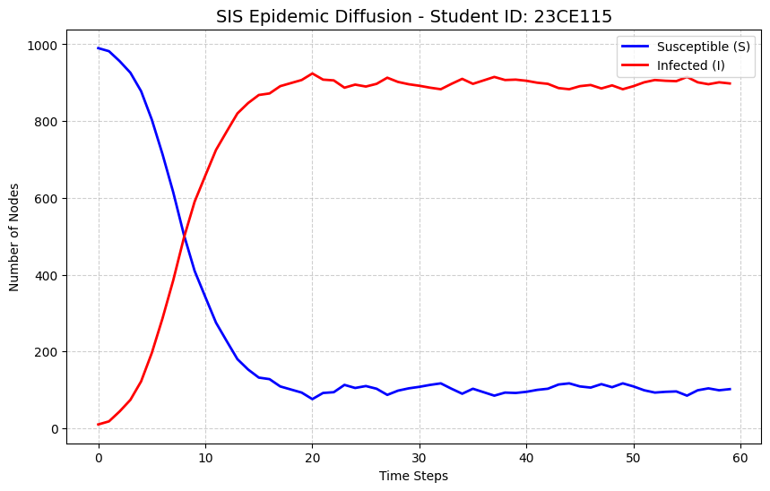
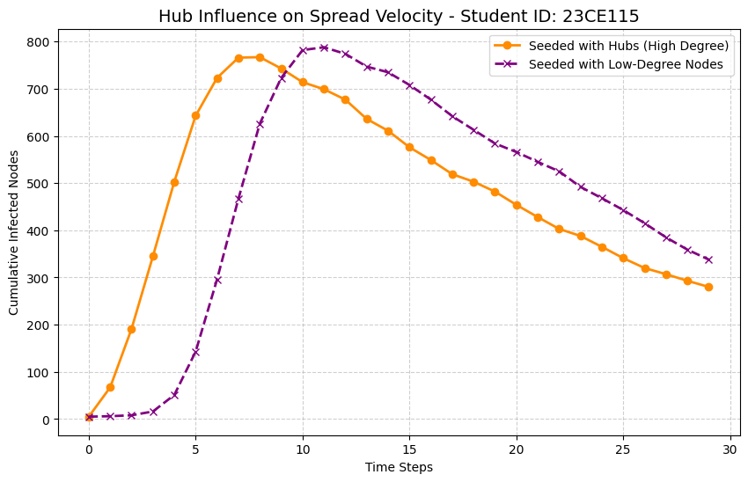
- Hub Influence Analysis Plot: (Paste spread velocity when seeding high-degree vs low-degree nodes)

Key Questions & Data Interpretation
- How does network structure influence spread?
  - Answer:
- Clustering Coefficient: Real-world social networks such as Facebook have high clustering due to triadic closure. This creates dense local groups where an infection can circulate repeatedly among mutual connections, which may temporarily slow global transmission as local groups become saturated.
- Average Path Length: Social networks generally exhibit the small-world phenomenon, where the average path length between nodes is relatively short. This allows an epidemic to move rapidly between different parts of the network, resulting in faster global diffusion.
- Degree Distribution: Scale-free networks have a heavy-tailed degree distribution, where most nodes have few connections while a small number of nodes act as highly connected hubs. These hubs can significantly influence the spread and persistence of an epidemic because they provide many possible transmission pathways.
- What is the role of key (highly connected) nodes in diffusion dynamics?
  - Answer:
    - Super-Spreaders: Nodes with high centrality can act as structural catalysts or super-spreaders. In the Hub Influence Analysis Plot, infection seeded through the top-5 hubs resulted in a rapid outbreak, infecting more than 75% of the network within 7 steps.
    - Contagion Bridges: Highly connected hubs can connect otherwise separate or sparsely connected communities. When such nodes become infected, they can transmit the disease across multiple clusters simultaneously, accelerating the outbreak compared with infection starting from low-degree peripheral nodes.

Learning Outcomes
(Summarize key findings regarding viral marketing and epidemic containment strategies)
- Viral Marketing: For maximizing information dissemination, product adoption, or marketing cascades, targeting highly connected nodes or key influencers as initial seed nodes can improve the speed and reach of information throughout the network.
- Epidemic Containment: In scale-free networks, targeted immunization of highly connected hub nodes can be more effective than random vaccination. Protecting these hubs can disrupt major transmission pathways and help reduce the possibility of widespread outbreaks.

